

Climograph Investigation

SUBJECT: Climate, graphing, and weather variables.

GRADE LEVEL: 6th – 8th

DEPTH OF KNOWLEDGE LEVEL: 2 and 3

AUTHOR: Dr. Lawrence Rudd, School of Education, Nevada State College, Lawrence.rudd@nsc.edu

NEXT GENERATION SCIENCE STANDARDS:

1. Graphs, charts, and images can be used to identify patterns in data. (MS-ESS3-2)
2. Weather and climate are influenced by interactions involving sunlight, the ocean, the atmosphere, ice, landforms, and living things. These interactions vary with latitude, altitude, and local and regional geography, all of which can affect oceanic and atmospheric flow patterns. (MS-ESS2-6)
3. Ask questions to identify and clarify evidence of an argument. (MS-ESS3-5)
4. Science assumes that objects and events in natural systems occur in consistent patterns that are understandable through measurement and observation. (MS-LS4-1), (MS-LS4-2)

PRIOR KNOWLEDGE:

Students will know how to draw and interpret graphs. Students will be familiar with weather variables and be able to define climate.

INTRODUCTORY ACTIVITY:

Carefully examine the seven climographs. What information on the graphs indicates that all of the stations are in the northern hemisphere? Work in groups to create an explanation. Make a sketch of what a climograph for a similar climate in the southern hemisphere would look like.

CONCEPT/SKILL DEVELOPMENT:

**Objective:**

The purpose of this investigation is to be able to read and interpret a climograph.

**Materials:**

Climographs of each transect measurement station.

**Important Terms:**

Climograph

Climate

**Diving question:**

What essential information does a climograph display and how can this information be used to better understand climate?

**Background Information**

Data from the transect measurement stations has been collected since the spring of 2011. Climographs are usually made using data that has been collected over a long time period (30 or more years). This discrepancy results in the climographs based on transect data exhibiting more variability than would be expected, especially in the precipitation curves. These graphs were made in 2013 based on two years of data from each of the transect data stations. As more years of data are gathered the extent to which these graphs represent the true climate at each data collection site will improve. Part B of this investigation involves comparing this set of graphs to a second set of graphs created from data from 1980 to 2012.

While you are working on the introductory activity, visit the site:

<http://sensor.nevada.edu/NCCP/Climate%20Monitoring/Equipment.aspx>

to examine both the instrumentation at each transect site as well as the location of the data transects themselves.

**Resources**

<http://www.weather.com/encyclopedia/>

Descriptions of a variety of storms and weather phenomena in an encyclopedic format.

<http://www.exploringweather.com/index.html>

A site that focuses on storms, as well as the process of weather forecasting. This site also includes a useful glossary of weather terms.

<http://sensor.nevada.edu/NCCP/Default.aspx>

The Nevada Climate Change Portal. This site explains the Nevada Climate Change project.

<http://daymet.ornl.gov/custom_home>

This site gives access to a model that provides weather data for North America from 1980 to 2011. The Daymet model was used to create the long-term climographs (Figures 8-14) used in this investigation. Click on Daily Data for a Single Pixel in the left-hand column to get weather data for any location in North America.

<http://www.nws.noaa.gov/om/coop/what-is-coop.html>

A description of the National Weather Service’s Cooperative Observer Program (COOP). This description also includes an interesting history of the program. Links to various COOP sites throughout the country are also included. COOP data was used to make the climograph of the Desert Game Range, figure 15.

<http://www.raws.dri.edu/documents/RAWS.pdf>

Fact sheet describing the RAWS program and the instrumentation on each of the RAWS weather stations.

<http://www.raws.dri.edu/wraws/nvutF.html>

Interactive map showing all of the Remote Automated Weather Station (RAWS) sites in Nevada, Utah, and parts of Arizona and California.

**Investigation (Part 1):**

1. Examine the seven climographs. How are all the temperature curves similar? Why do you think that this similarity exists?
2. According to the temperature curves, which sites are at the highest elevations and which sites are at the lowest elevations? How could you tell?
3. How are all the precipitation curves similar? Which sites have the most similar precipitation curves?
4. Identify a location on one of the graphs that you think may not accurately represent the climate of that area. Explain your choice.
5. Name two or more factors that influence the amount of precipitation that falls in any given location.
6. Use your answer to question 5 to pick out the lowest elevation sites and the highest elevation sites. Do your choices correspond to your answers to question 3? Explain.

**Investigation (Part 2):**

1. Examine the climographs in figures 8-14. Compare each climograph to the climograph of the same transect site in figures 1-7. Pick two pairs of climographs and describe how the temperature curves are different in each pair.
2. Examine the climographs in figures 8-14. Compare each climograph to the climograph of the same transect site in figures 1-7. Pick two pairs of climographs and describe how the precipitation data is different in each pair.
3. Why do you think that the differences that you described in question 1 and 2 exist?
4. Which graphs do you think do a better job of showing the climate of these places? Why?

**Investigation (Part 3):**

1. Examine the climograph in figure 15. This data in this climograph was collected over a period of 65 years at a weather station located about ½ kilometer from the Sheep Range Desert Shrub Transect Station. Compare the climograph in figure 15 to the climographs in figures 1 and 8. Describe at least two similarities and two differences between these three graphs.
2. Why do you think that the differences that you described in question 1 exist?
3. Do you think that the climate in this area has changed over the past 65 years? Make at least three statements to justify your answer.

**Extension**

What do you think that a climograph would look like for where you live? Describe the climate (temperature and precipitation distribution over a typical year) for where you live and then draw a simple sketch graph to go along with your description.

CLOSING ACTIVITY:

Have students should work in groups to complete the third investigation. Use the discussions that take place in each group as the basis for a whole-class discussion of the nature of climate and how the climate of the area shown on the three graphs in part 3 of this investigation has changed through time.

**References**

Thornton, P.E., H. Hasenauer, and M.A. White. 2000. Simultaneous estimation of daily solar radiation

and humidity from observed temperature and precipitation: An application over complex terrain in Austria. Agricultural and Forest Meteorology 104:255-271.

Thornton, P.E. and S.W. Running. 1999. An improved algorithm for estimating incident daily solar

radiation from measurements of temperature, humidity, and precipitation. Agriculture and Forest Meteorology. 93:211-228.

Thornton, PE, MM Thornton, BW Mayer, N Wilhelmi, Y Wei, RB Cook. 2012. Daymet: Daily surface

weather on a 1 km grid for North America,1980 - 2012. Acquired online (<http://daymet.ornl.gov/>) on [insert acquisition date here: DD/MM/YYYY] from Oak Ridge National Laboratory Distributed Active Archive Center, Oak Ridge, Tennessee, U.S.A. doi:10.3334/ORNLDAAC/Daymet_V2.

**Figures 1-7.** Climographs based on data from the Nevada Climate-ecohydrology Assessment Network (<http://sensor.nevada.edu/NCCP/Climate%20Monitoring/Network.aspx>) transects in the Sheep and Snake Ranges.

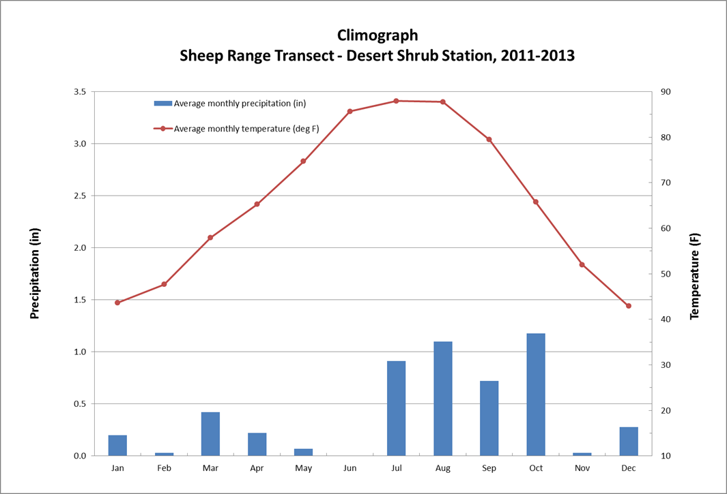

**Figure 1.**

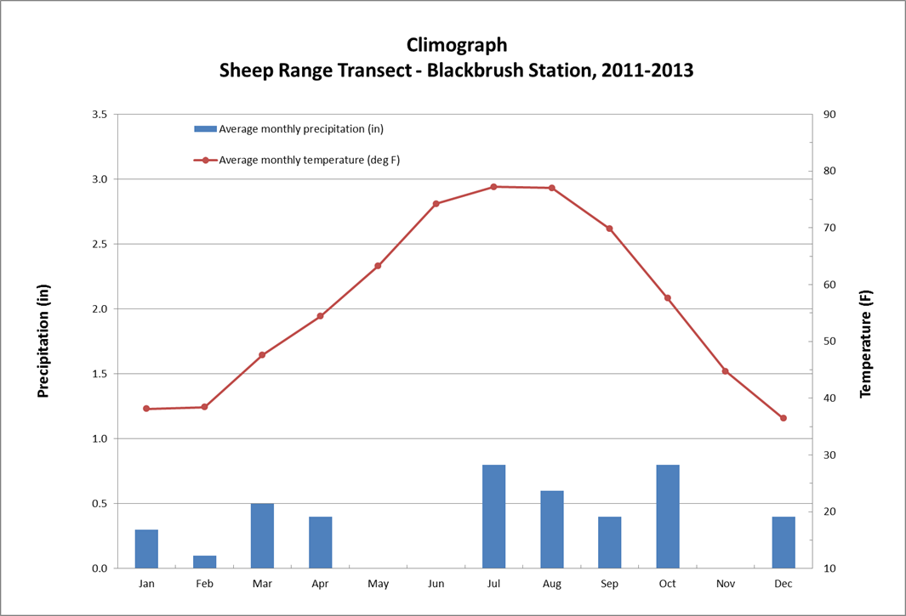

**Figure 2.**

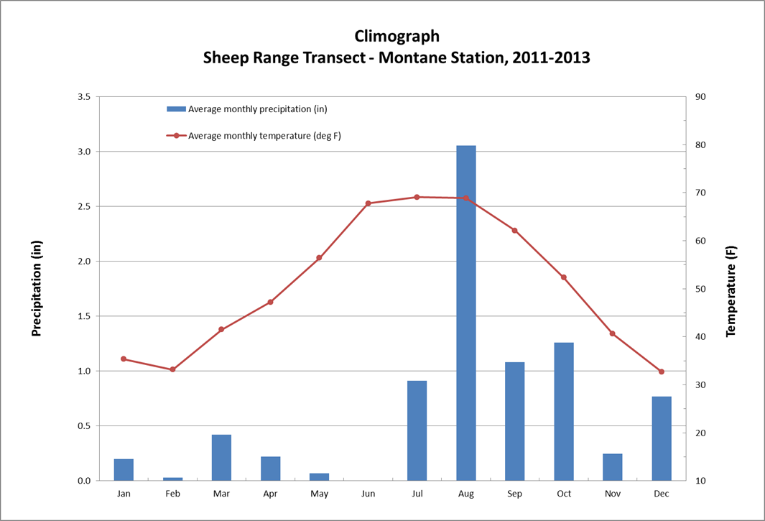

**Figure 3.**

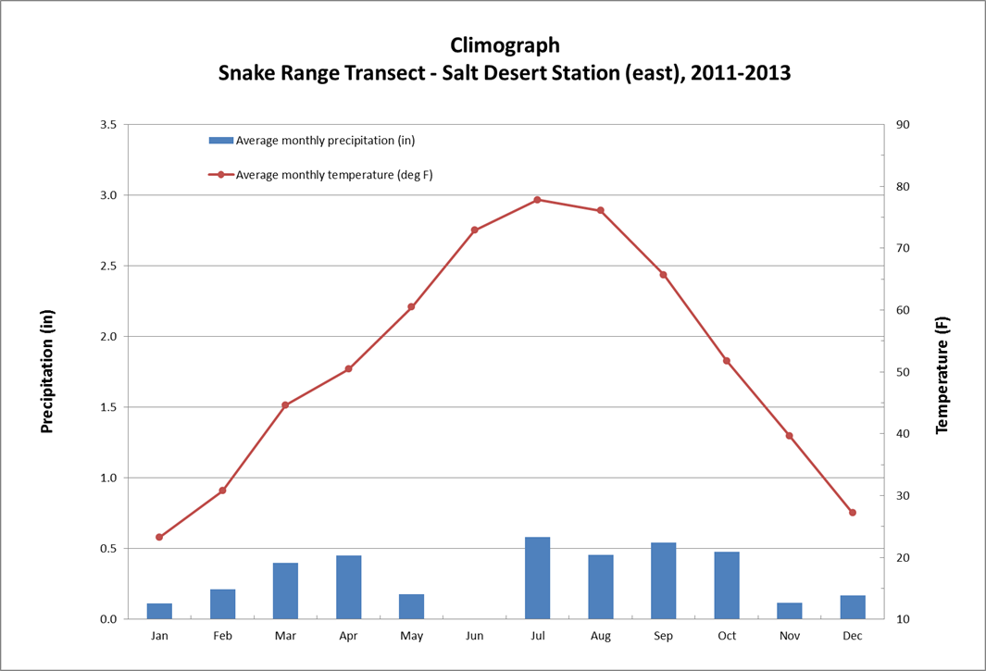

**Figure 4.**

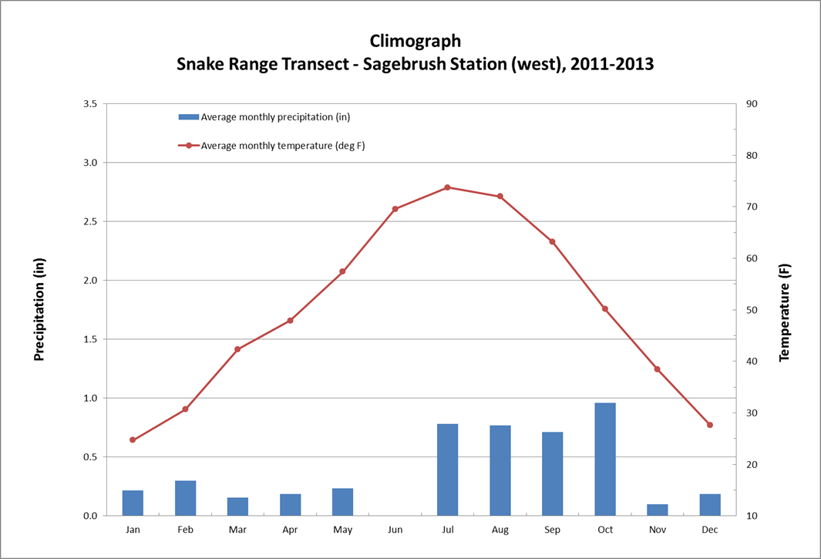

**Figure 5.**

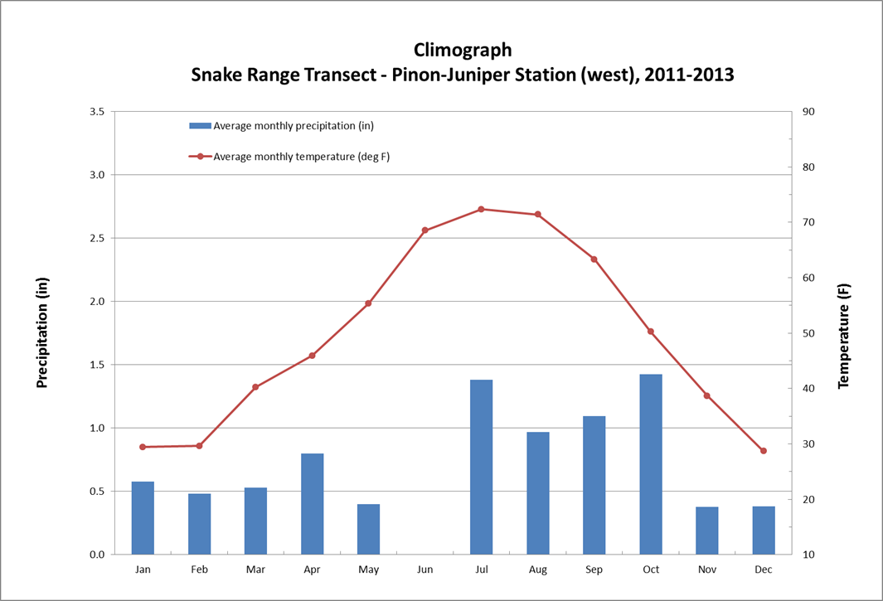

**Figure 6.**

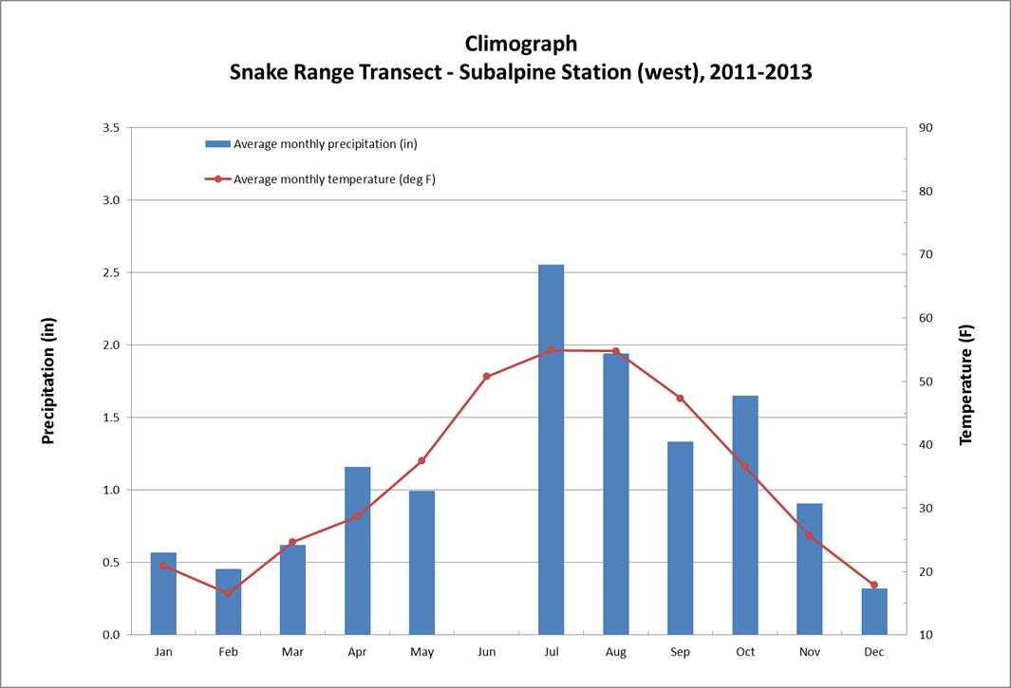

**Figure 7.**

**Figures 8-14.** Climographs based on data from the Daymet model of Daily Surface Weather and Climatological Summaries (<http://daymet.ornl.gov/custom_home>). The Daymet model was applied to the transect locations from part 1 of this investigation to create a set of precipitation and temperature data that extends from 1980 to 2012 for each transect site. Compare these graphs to figures 1-7 when you answer the questions for part 2 of this investigation.

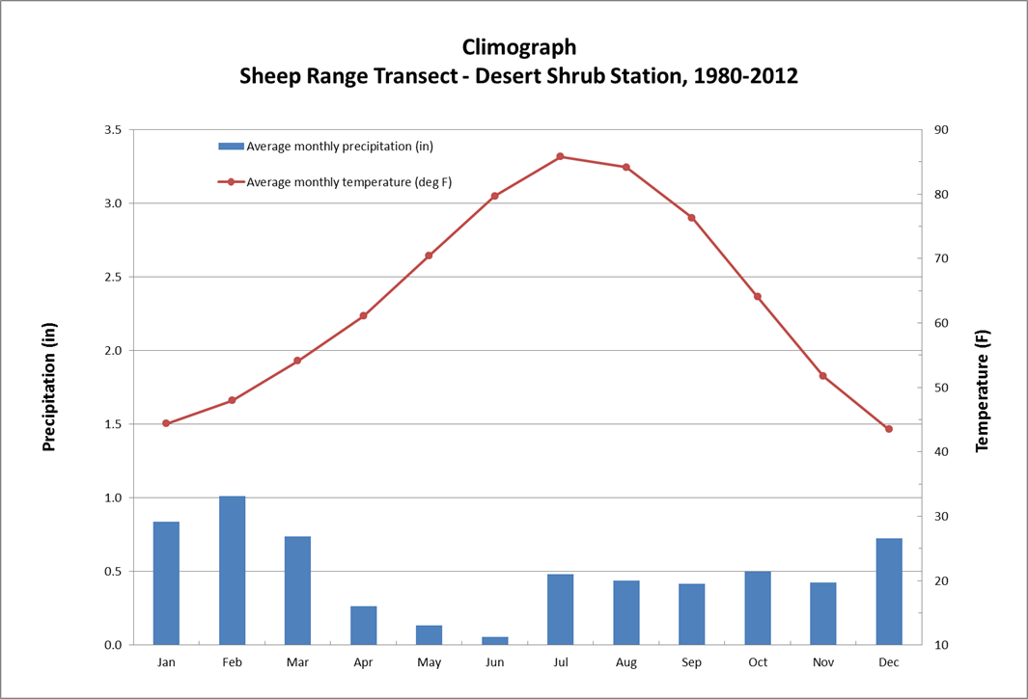

**Figure 8.**

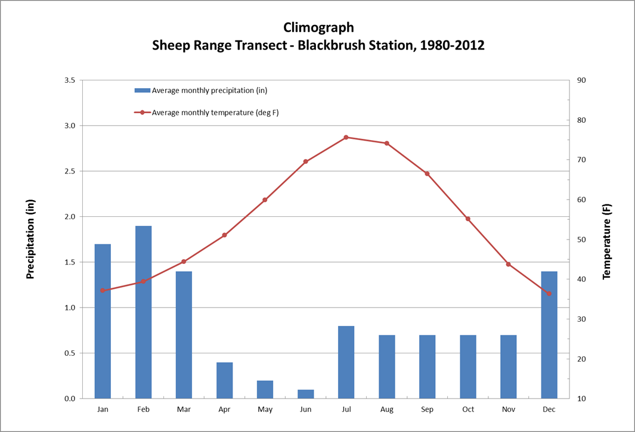

**Figure 9.**

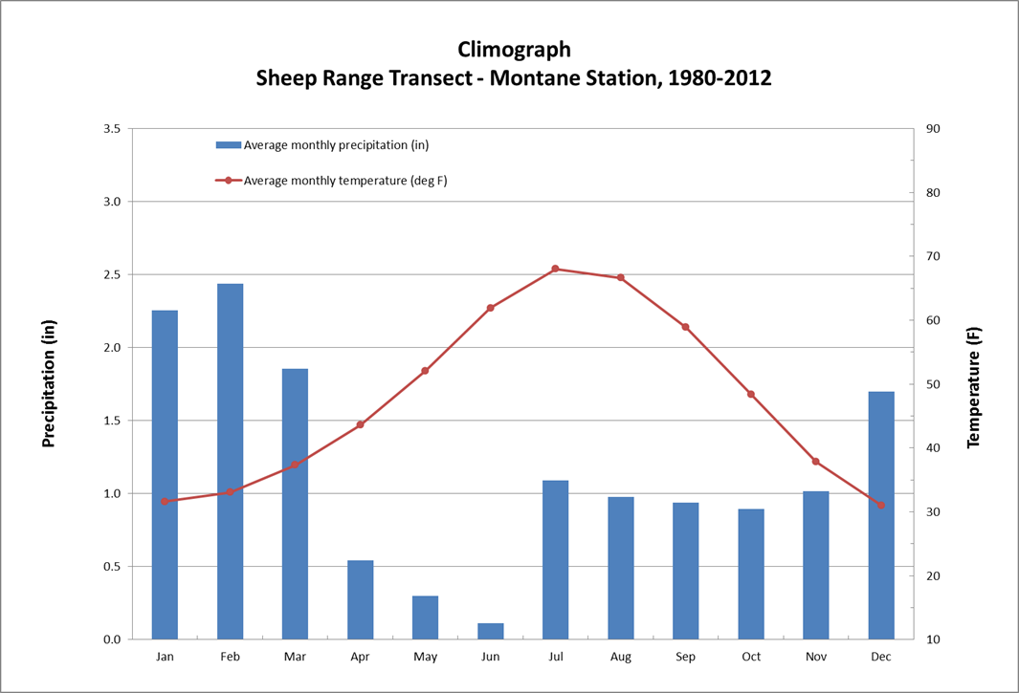

**Figure 10.**

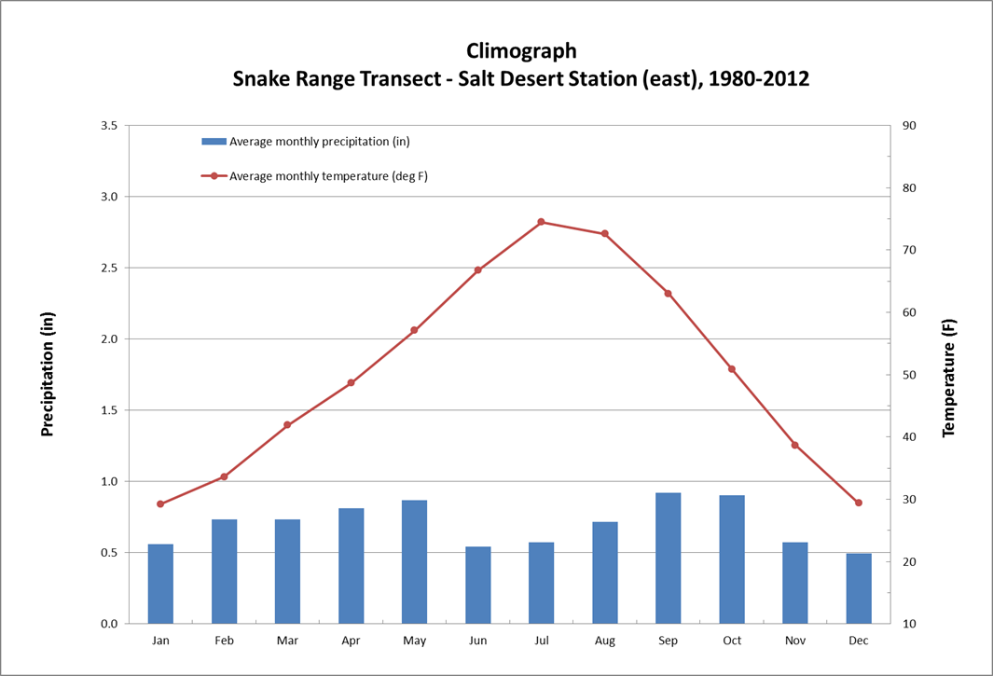

**Figure 11.**

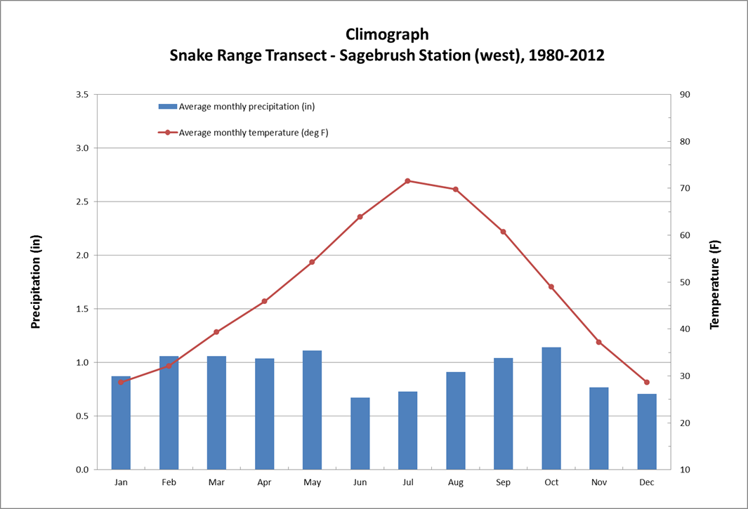

**Figure 12.**

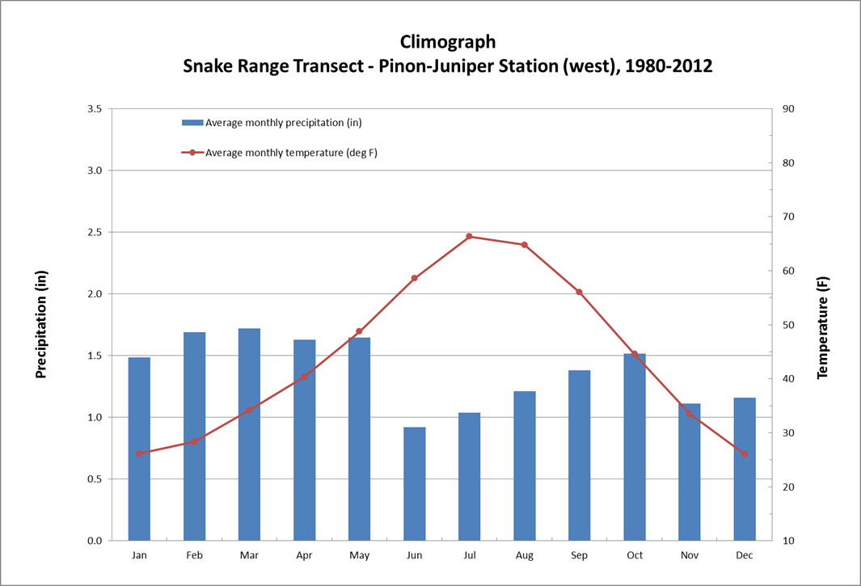

**Figure 13.**

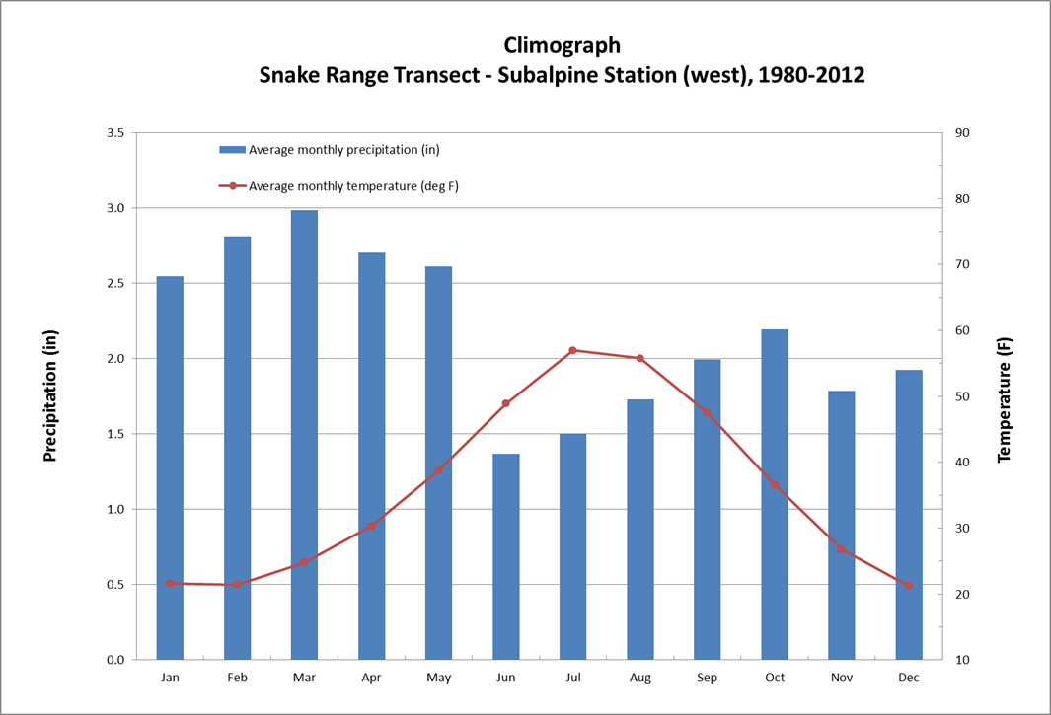

**Figure 14.**

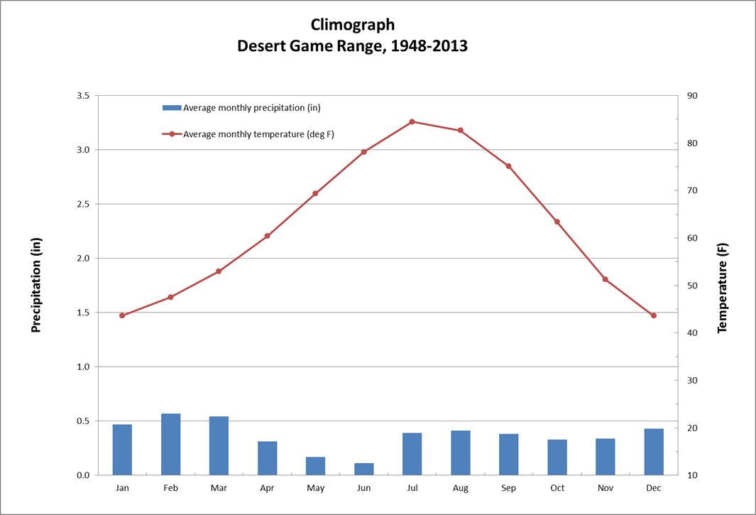

**Figure 15.** Climograph of the Desert Game Range from 1948 to 2013. The Desert Game Range is now called the Desert National Wildlife Refuge and this weather station is located on the western edge of the Sheep Range in Corn Creek (Nevada). The weather station where this data was recorded is part of the National Weather Service’s Cooperative Observer Program (COOP) and is located about 0.5 kilometers (~0.3 miles) northwest of the Sheep Range Desert Shrub Transect Station, which is shown in figures 1 and 8.